Simulation and Performance Evaluation of People-Process-Data-Things IoE Framework using Edge/Fog-to-Cloud Pipeline with MQTT, Node-RED, and Benchmarking of 5G/6G Communication for IoE Applications based on Throughput, Latency, Reliability and Energy Efficiency
Objective:
To simulate a People-Process-Data-Things (PPDT) IoE framework in which sensor data flows through an edge/fog-to-cloud pipeline using MQTT and Node-RED, and to benchmark simulated 5G and 6G communication for IoE applications in terms of throughput, latency, reliability and energy efficiency.
Procedure:
- Part A: simulate 120 sensor devices (Sensor_001 to Sensor_120), each linked to one person (Operator_A, Operator_B, Technician_C, Admin_D) and one process (Monitoring, Alerting, Control, Logging), with a temperature reading drawn from a normal distribution (mean 28, SD 4).
- Model message delivery: MQTT succeeds with probability 0.97 and Node-RED with probability 0.985; a message is delivered only if both succeed.
- Assign each device simulated processing latencies at the edge (mean 18 ms), fog (mean 35 ms) and cloud (mean 70 ms), and compute the delivery rate and the average latency at each tier.
- Part B: generate 1,000 samples each for 5G and 6G of throughput, latency, reliability and energy per MB from normal distributions with set limits, and take the mean of each metric.
- Plot IoE delivery, edge/fog/cloud latency, 5G vs 6G throughput and 5G vs 6G latency.
Program:
import numpy as np
import pandas as pd
import matplotlib.pyplot as plt
import random

np.random.seed(21)
random.seed(21)

# ==================================================
# PART A: PEOPLE-PROCESS-DATA-THINGS IoE FRAMEWORK
# ==================================================

N = 120
people = ["Operator_A", "Operator_B", "Technician_C", "Admin_D"]
processes = ["Monitoring", "Alerting", "Control", "Logging"]

records = []

for i in range(N):
mqtt_ok = random.random() < 0.97
node_red_ok = random.random() < 0.985

records.append({
"Device": f"Sensor_{i+1:03d}",
"Person": random.choice(people),
"Process": random.choice(processes),
"Temperature": round(np.random.normal(28, 4), 2),
"Edge_ms": max(2, np.random.normal(18, 5)),
"Fog_ms": max(3, np.random.normal(35, 8)),
"Cloud_ms": max(5, np.random.normal(70, 15)),
"MQTT": mqtt_ok,
"Node_RED": node_red_ok,
"Delivered": mqtt_ok and node_red_ok
})

df = pd.DataFrame(records)

delivered = int(df["Delivered"].sum())
delivery_rate = delivered / N * 100

edge = df["Edge_ms"].mean()
fog = df["Fog_ms"].mean()
cloud = df["Cloud_ms"].mean()

print("PART A: IoE FRAMEWORK")
print("Devices simulated:", N)
print("Successful deliveries:", delivered)
print(f"Delivery rate: {delivery_rate:.2f}%")
print(f"Average Edge latency: {edge:.2f} ms")
print(f"Average Fog latency: {fog:.2f} ms")
print(f"Average Cloud latency: {cloud:.2f} ms")

# ===========================================
# PART B: 5G AND 6G COMMUNICATION BENCHMARKING
# ===========================================

samples = 1000
results = {}

for tech in ["5G", "6G"]:
if tech == "5G":
throughput = np.random.normal(850, 100, samples).clip(400, 1200)
latency = np.random.normal(10, 2, samples).clip(4, 18)
reliability = np.random.normal(99.0, 0.45, samples).clip(96, 99.9)
energy = np.random.normal(1.8, 0.25, samples).clip(1.0, 2.8)
else:
throughput = np.random.normal(1800, 180, samples).clip(900, 2500)
latency = np.random.normal(3, 0.8, samples).clip(1, 7)
reliability = np.random.normal(99.8, 0.12, samples).clip(99.2, 100)
energy = np.random.normal(1.3, 0.18, samples).clip(0.7, 2.0)

results[tech] = {
"Throughput (Mbps)": throughput.mean(),
"Latency (ms)": latency.mean(),
"Reliability (%)": reliability.mean(),
"Energy (J/MB)": energy.mean()
}

summary = pd.DataFrame(results).T

print("\nPART B: 5G/6G BENCHMARK")
print(summary.round(2))

# ============================
# PERFORMANCE GRAPHS
# ============================

fig, ax = plt.subplots(2, 2, figsize=(14, 9))

# Graph 1: IoE message delivery
ax[0, 0].bar(
["Delivered", "Not delivered"],
[delivered, N - delivered]
)
ax[0, 0].set_title("IoE: MQTT + Node-RED Delivery")
ax[0, 0].set_ylabel("Number of devices")
ax[0, 0].grid(axis="y", alpha=0.3)

# Graph 2: Edge/Fog/Cloud latency
ax[0, 1].bar(
["Edge", "Fog", "Cloud"],
[edge, fog, cloud]
)
ax[0, 1].set_title("Average Processing Latency")
ax[0, 1].set_ylabel("Latency (ms)")
ax[0, 1].grid(axis="y", alpha=0.3)

# Graph 3: Throughput comparison
ax[1, 0].bar(
["5G", "6G"],
[summary.loc["5G", "Throughput (Mbps)"],
summary.loc["6G", "Throughput (Mbps)"]]
)
ax[1, 0].set_title("5G vs 6G Throughput")
ax[1, 0].set_ylabel("Throughput (Mbps)")
ax[1, 0].grid(axis="y", alpha=0.3)

# Graph 4: Latency comparison
ax[1, 1].bar(
["5G", "6G"],
[summary.loc["5G", "Latency (ms)"],
summary.loc["6G", "Latency (ms)"]]
)
ax[1, 1].set_title("5G vs 6G Latency")
ax[1, 1].set_ylabel("Latency (ms)")
ax[1, 1].grid(axis="y", alpha=0.3)

plt.tight_layout()
plt.savefig("IoE_5G_6G_Output.png", dpi=180)
plt.show()

# Download the graph image in Google Colab
from google.colab import files
files.download("IoE_5G_6G_Output.png")

Output:
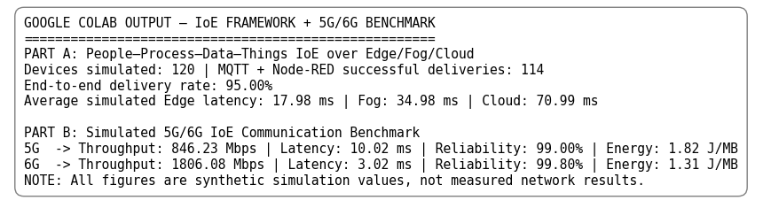
Fig. 1: Console output summary (Part A and Part B)
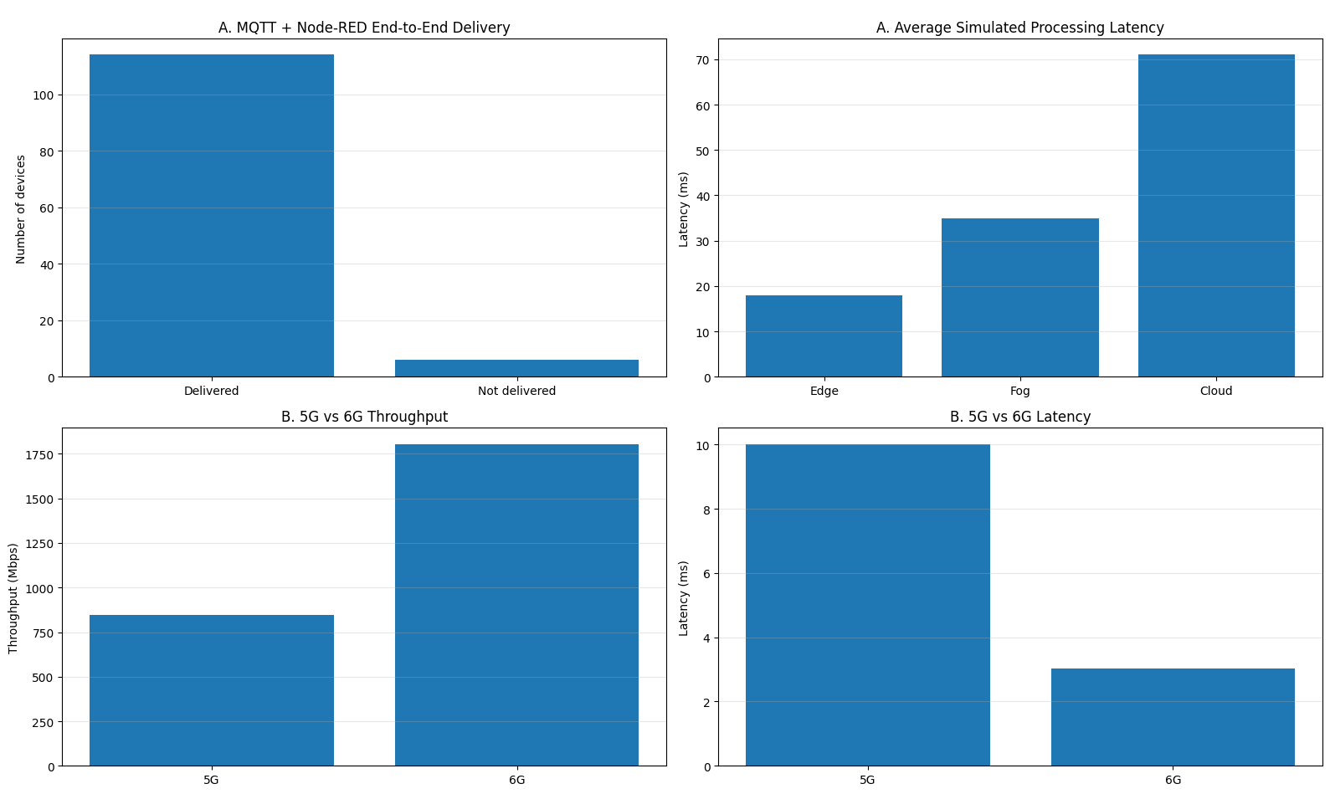
Fig. 2: Performance graphs (IoE delivery, edge/fog/cloud latency, 5G vs 6G throughput and latency)
Results:
Part A: PPDT IoE framework over edge, fog and cloud
Metric | Value
Devices simulated | 120
Successful deliveries (MQTT + Node-RED) | 114
End-to-end delivery rate | 95.00%
Average edge latency | 17.98 ms
Average fog latency | 34.98 ms
Average cloud latency | 70.99 ms

Part B: 5G vs 6G benchmark
Metric | 5G | 6G
Throughput (Mbps) | 846.23 | 1806.08
Latency (ms) | 10.02 | 3.02
Reliability (%) | 99.00 | 99.80
Energy (J/MB) | 1.82 | 1.31

In Part A, 114 of 120 messages were delivered, giving a 95.00% delivery rate. Processing latency grows from edge (17.98 ms) to fog (34.98 ms) to cloud (70.99 ms), so cloud processing takes about four times as long as edge processing. In Part B, 6G gives about 2.1 times the throughput of 5G (1806.08 vs 846.23 Mbps), about 70% lower latency (3.02 vs 10.02 ms), slightly higher reliability (99.80% vs 99.00%) and about 28% lower energy per MB (1.31 vs 1.82 J/MB).
Result:
The simulated PPDT IoE framework delivered 95.00% of device messages through MQTT and Node-RED, and latency was lowest at the edge and highest at the cloud, so processing data close to the things reduces delay for time-sensitive IoE tasks. In the benchmark, 6G outperformed 5G on all four measures: throughput, latency, reliability and energy efficiency. All figures are synthetic simulation values, not measured network results.

